Rural Health Management Project
Objective:
To solve common problems related to health issues in rural areas.
Platform required:
- Windows ( XP or later)
Steps:
1. Open the RuralMangement.exe file
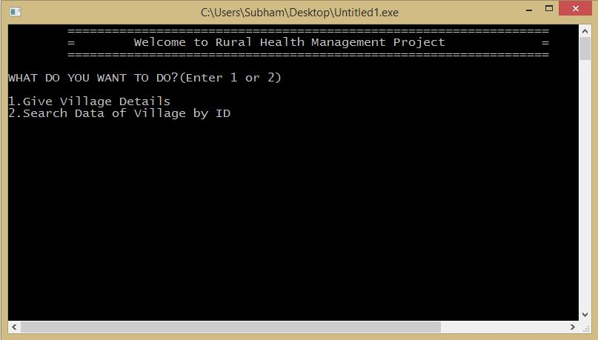

2. Press 1 to Give Village details.
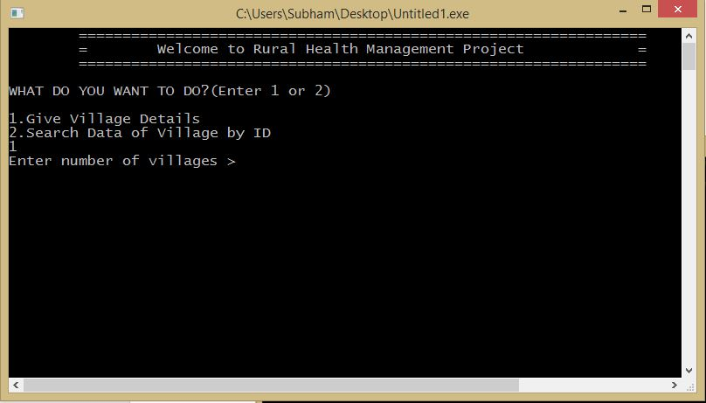

3. Give Number of villages of your choice .
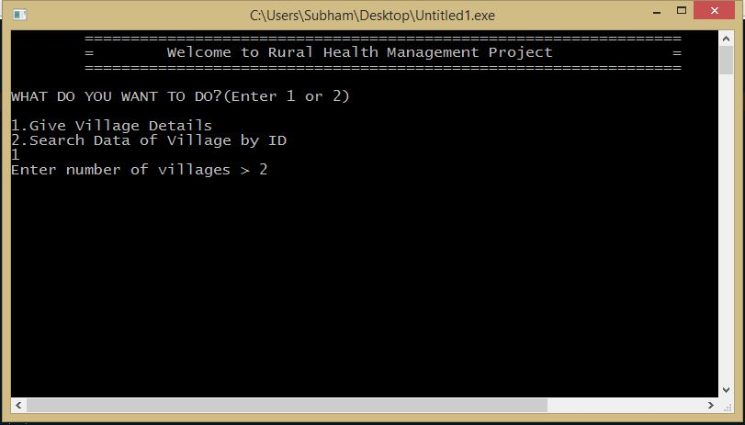

4.Enter the Details of the villages consecutively.
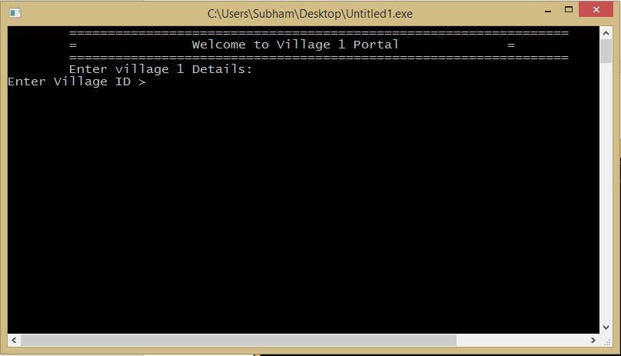
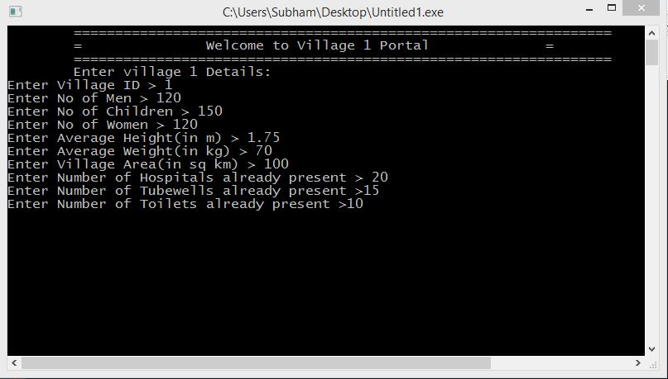

5. Press 1/2/3 to choose your problem, for example 1 for Hospital related problems
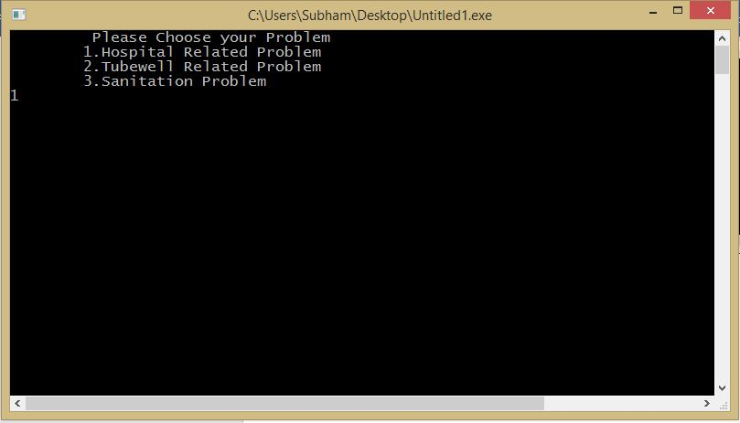
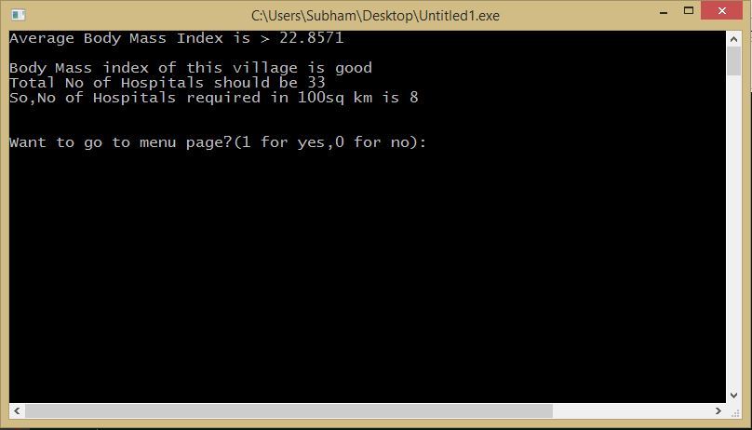

Now Body Mass Index is calculated with the help of average height and weight of the average population , so that we can calculate number of hospitals to be made in that area.

6. Press 0 to enter the details of next village or 1 for another problem. For example its 0.
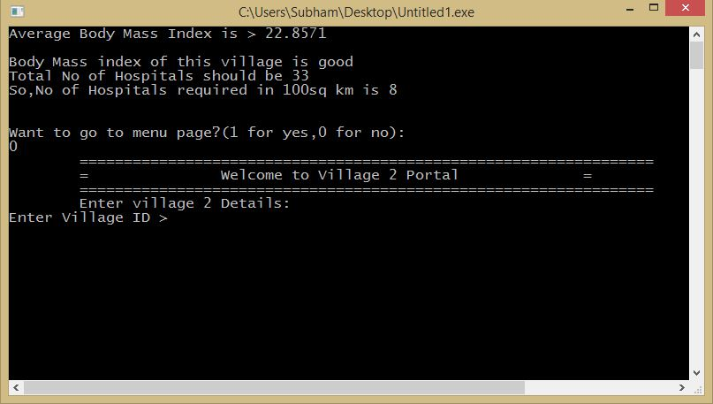

7. Enter the details of next village similarly.
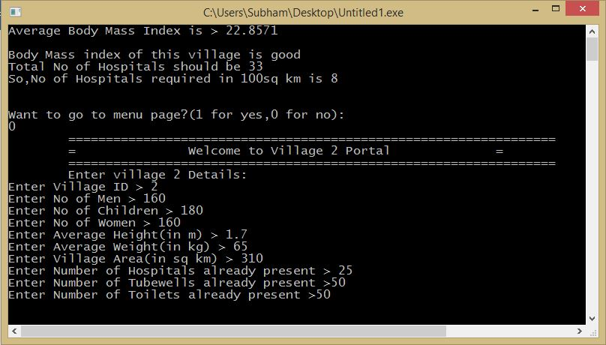

8. Now Either you can exit to Menu page or to Main page.
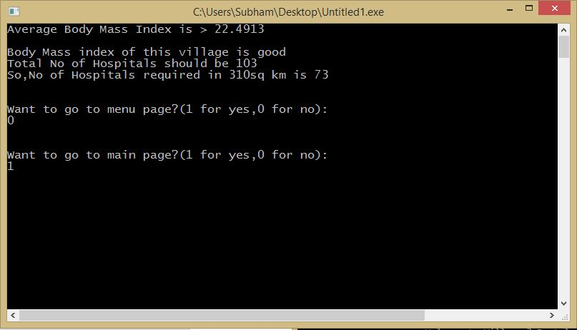

9. For example we are going to main page by pressing 1
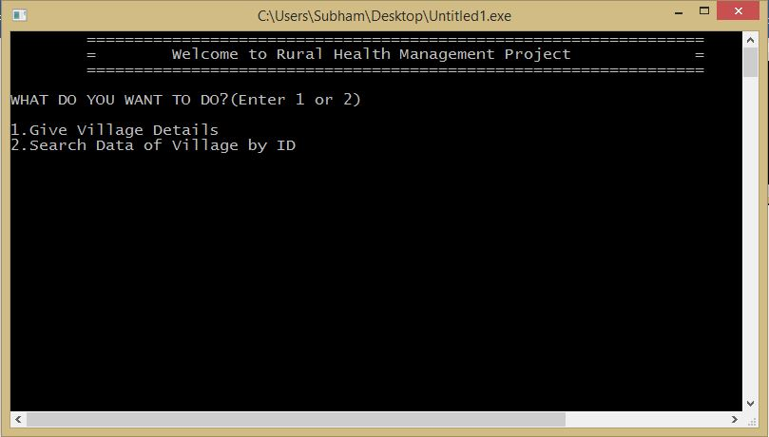

10. Now you can search any village’s data by its ID.
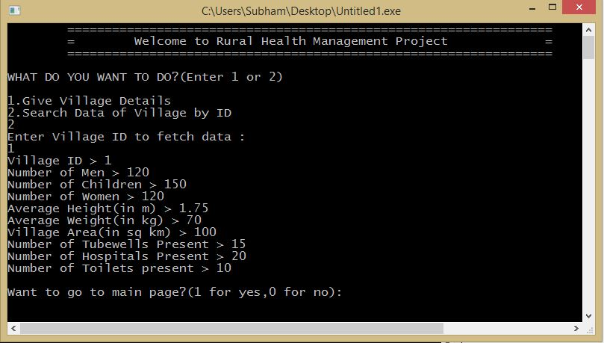

11. Now Press 0 to EXIT.
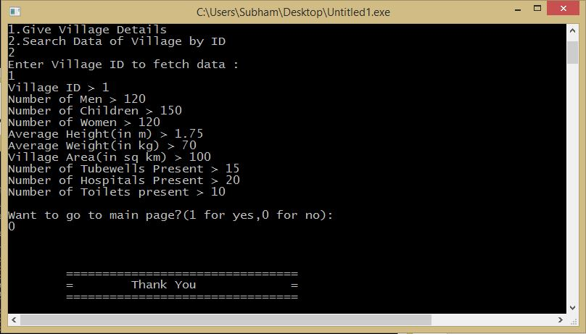

Precautions:
1. User should not Search data before entering the details for the village
Future Scope:
1. This Application can be used to find out less number of hospitals, tube wells and Toilets in village.

